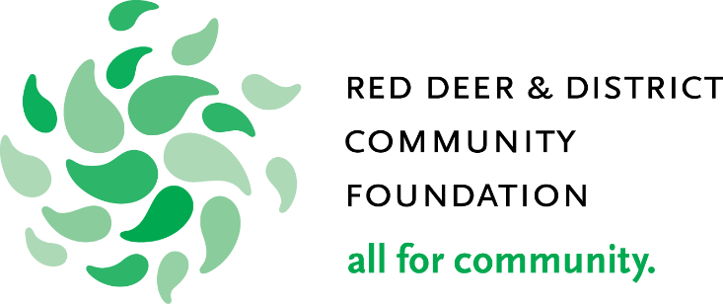

Grant Application
Smart and Caring Communities Fund

The Red Deer & District Community Foundation is a community catalyst committed to building a legacy which strengthens the quality of life in Red Deer and the surrounding area.

Guiding Principles of the Red Deer & District Community Foundation

A Community Catalyst
We work with community and for community by supporting organizations that demonstrate a collaborative approach. We support innovative projects that align with our guiding principles. Not every new idea will work, but we will learn from every project.

Quality of Life
We are committed to strengthening the quality of life in Red Deer and the surrounding area. We build on the strengths of the community and address issues that detract from community wellbeing by supporting organizations that share this goal with us.

Stewardship
We are building a community legacy because we never touch our capital pool of money. While our capital base grows, we use the income earned to support community. We are committed to investing wisely, managing efficiently and looking for ways to maximize resources and results through alliances and partnerships.

Proactive Attitude
The Foundation does not necessarily wait for applications. Through strong community relationships we identify and address issues with other community organizations and district municipalities.

Volunteer Support
Programs that utilize a strong volunteer force, or are dedicated to supporting volunteers, will be priority for Foundation support.

Independence for Individuals
Community development means building the capacity of individuals to be independent and self-sustaining. We will give strong consideration to projects that support this principle.

Application Process

- Please contact the Red Deer & District Community Foundation office to discuss your proposal before completing and submitting the application package.

- Only QUALIFIED DONEES, as defined by the Canadian Income Tax Act, are eligible for Foundation grants, including, but not limited to, registered charities, registered Canadian amateur athletic associations; certain housing corporations providing low-cost accommodation to the elderly and local municipalities

- The Board will not consider applications for deficit funding of projects.

- The grant application submission deadline for Fall 2020 will be Thursday, October 1 at 4:30pm. Please contact the office for future dates. Grant applications submitted after the grant submission deadline will not be considered for funding and will be returned.

- A complete grant package must be delivered (not postmarked) to the Foundation office on or before the submission deadline. A complete grant application will include all of the following:

The original application PLUS six (6) copies of each:
- Part A and Part B (the downloadable “Smart & Caring Grant Application”) are required.
- Audited financial statements (as per your organization by-laws)

One (1) copy of each:

- Evidence of Charitable status with Canada Revenue Agency (front page of your T3010)
- Minutes of the Board meeting authorizing this grant request
- Certificate of Incorporation
- Original signed Declaration of Intent (the downloadable “Declaration of Intent”) and Statutory Declaration (the downloadable “Statutory Declaration”)

- Grant allocations will be announced approximately six weeks after the grant submission deadline.

- Grant recipients are fully accountable to the Foundation for funds received. As such, applicants will be required to sign the Declaration of Intent and the Statutory Declaration (separate downloads) and fulfill the requirements therein.

*To assist us in raising the profile of the Foundation all recipients are required to acknowledge their partnership with the Red Deer & District Community Foundation in all project communications.

